IN404 Unit 5 Assignment: Support Vector Machine
Shubham Raj
Purdue University Global
IN404 – Machine Learning

1. Python Code and Execution
I completed the Python program (IN404_Unit5.py), which is attached separately. In this program, I read two CSV datasets (IN404_Unit5and6_1.csv and IN404_Unit5and6_2.csv), explored both dataframes, converted the Date column from an object to a datetime and then to a float, defined the feature matrix X and target vector y, performed a train/test split, and trained a Support Vector Machine (SVM) classifier. I have included screenshots of the execution output below.
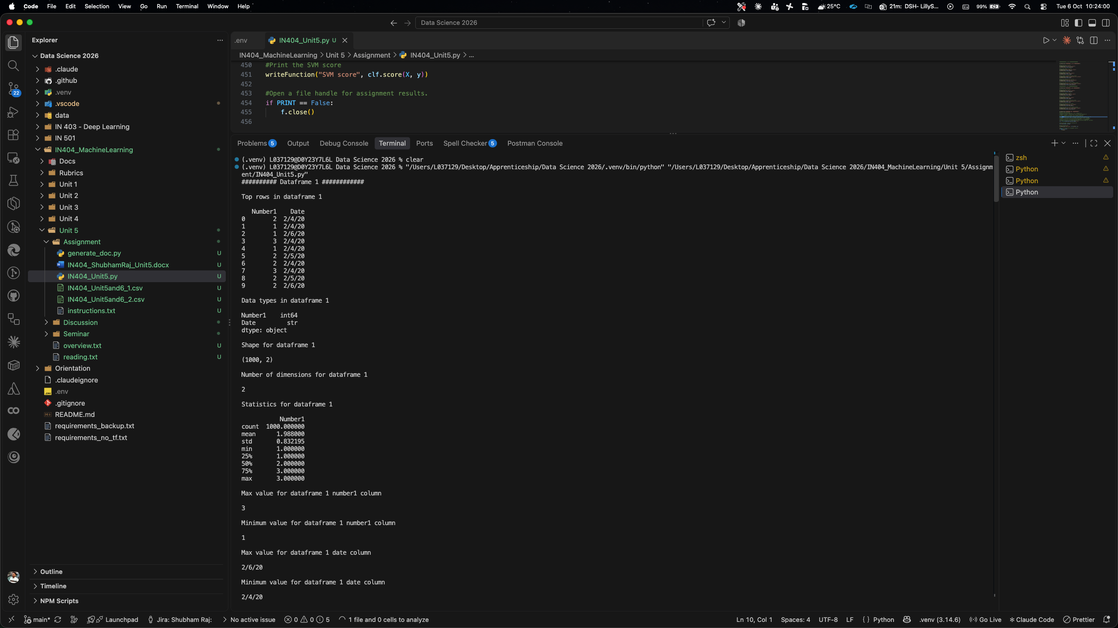
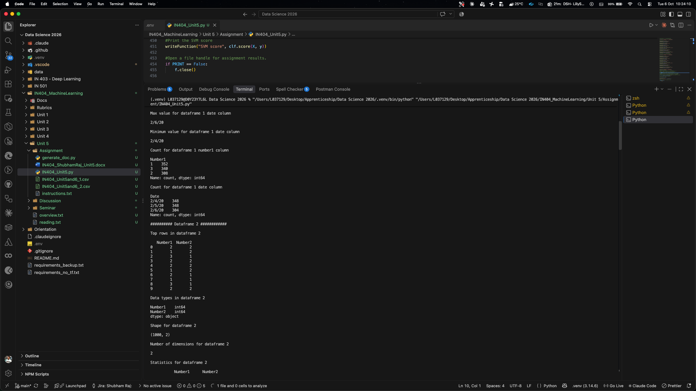
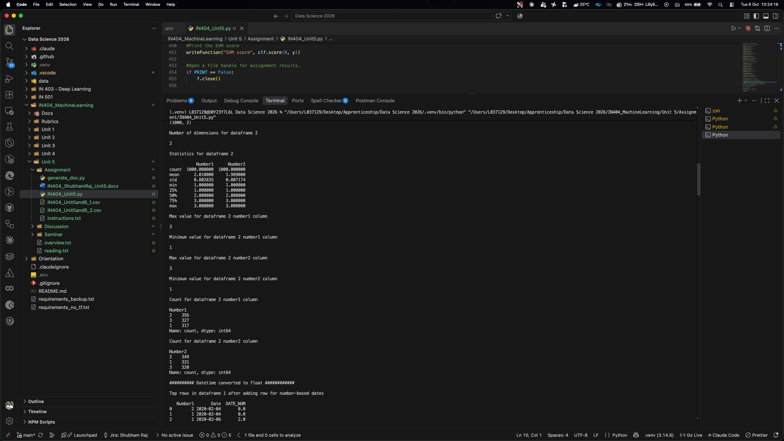
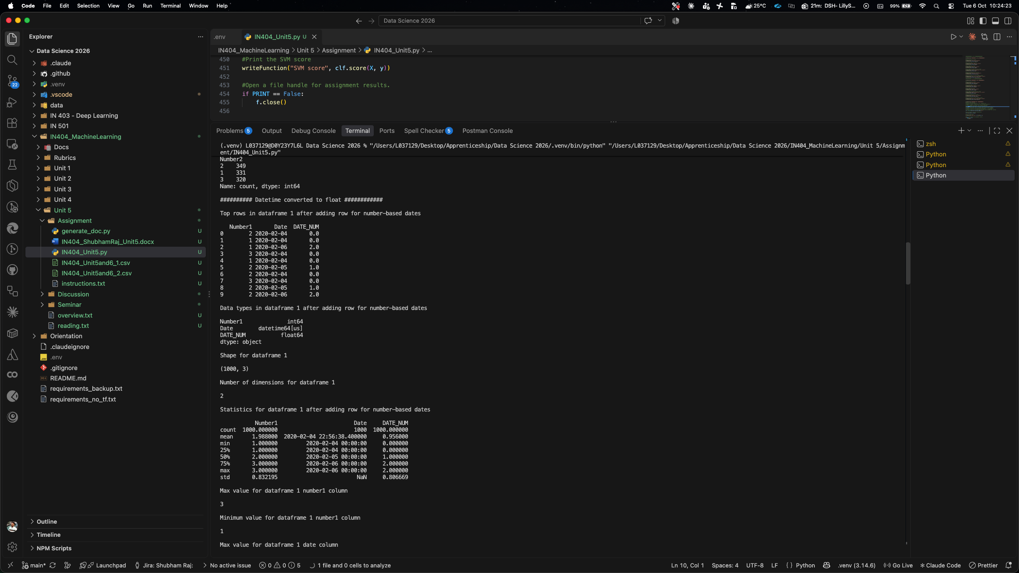
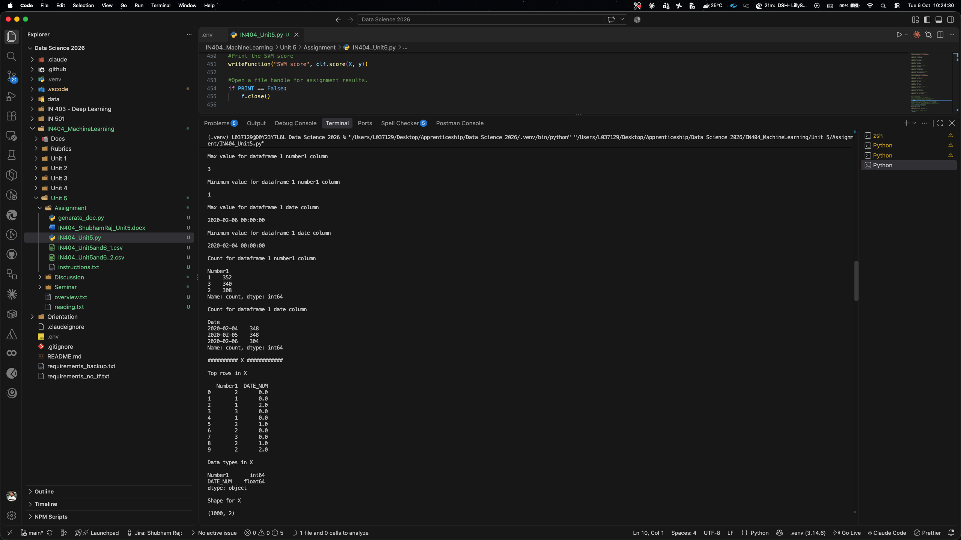
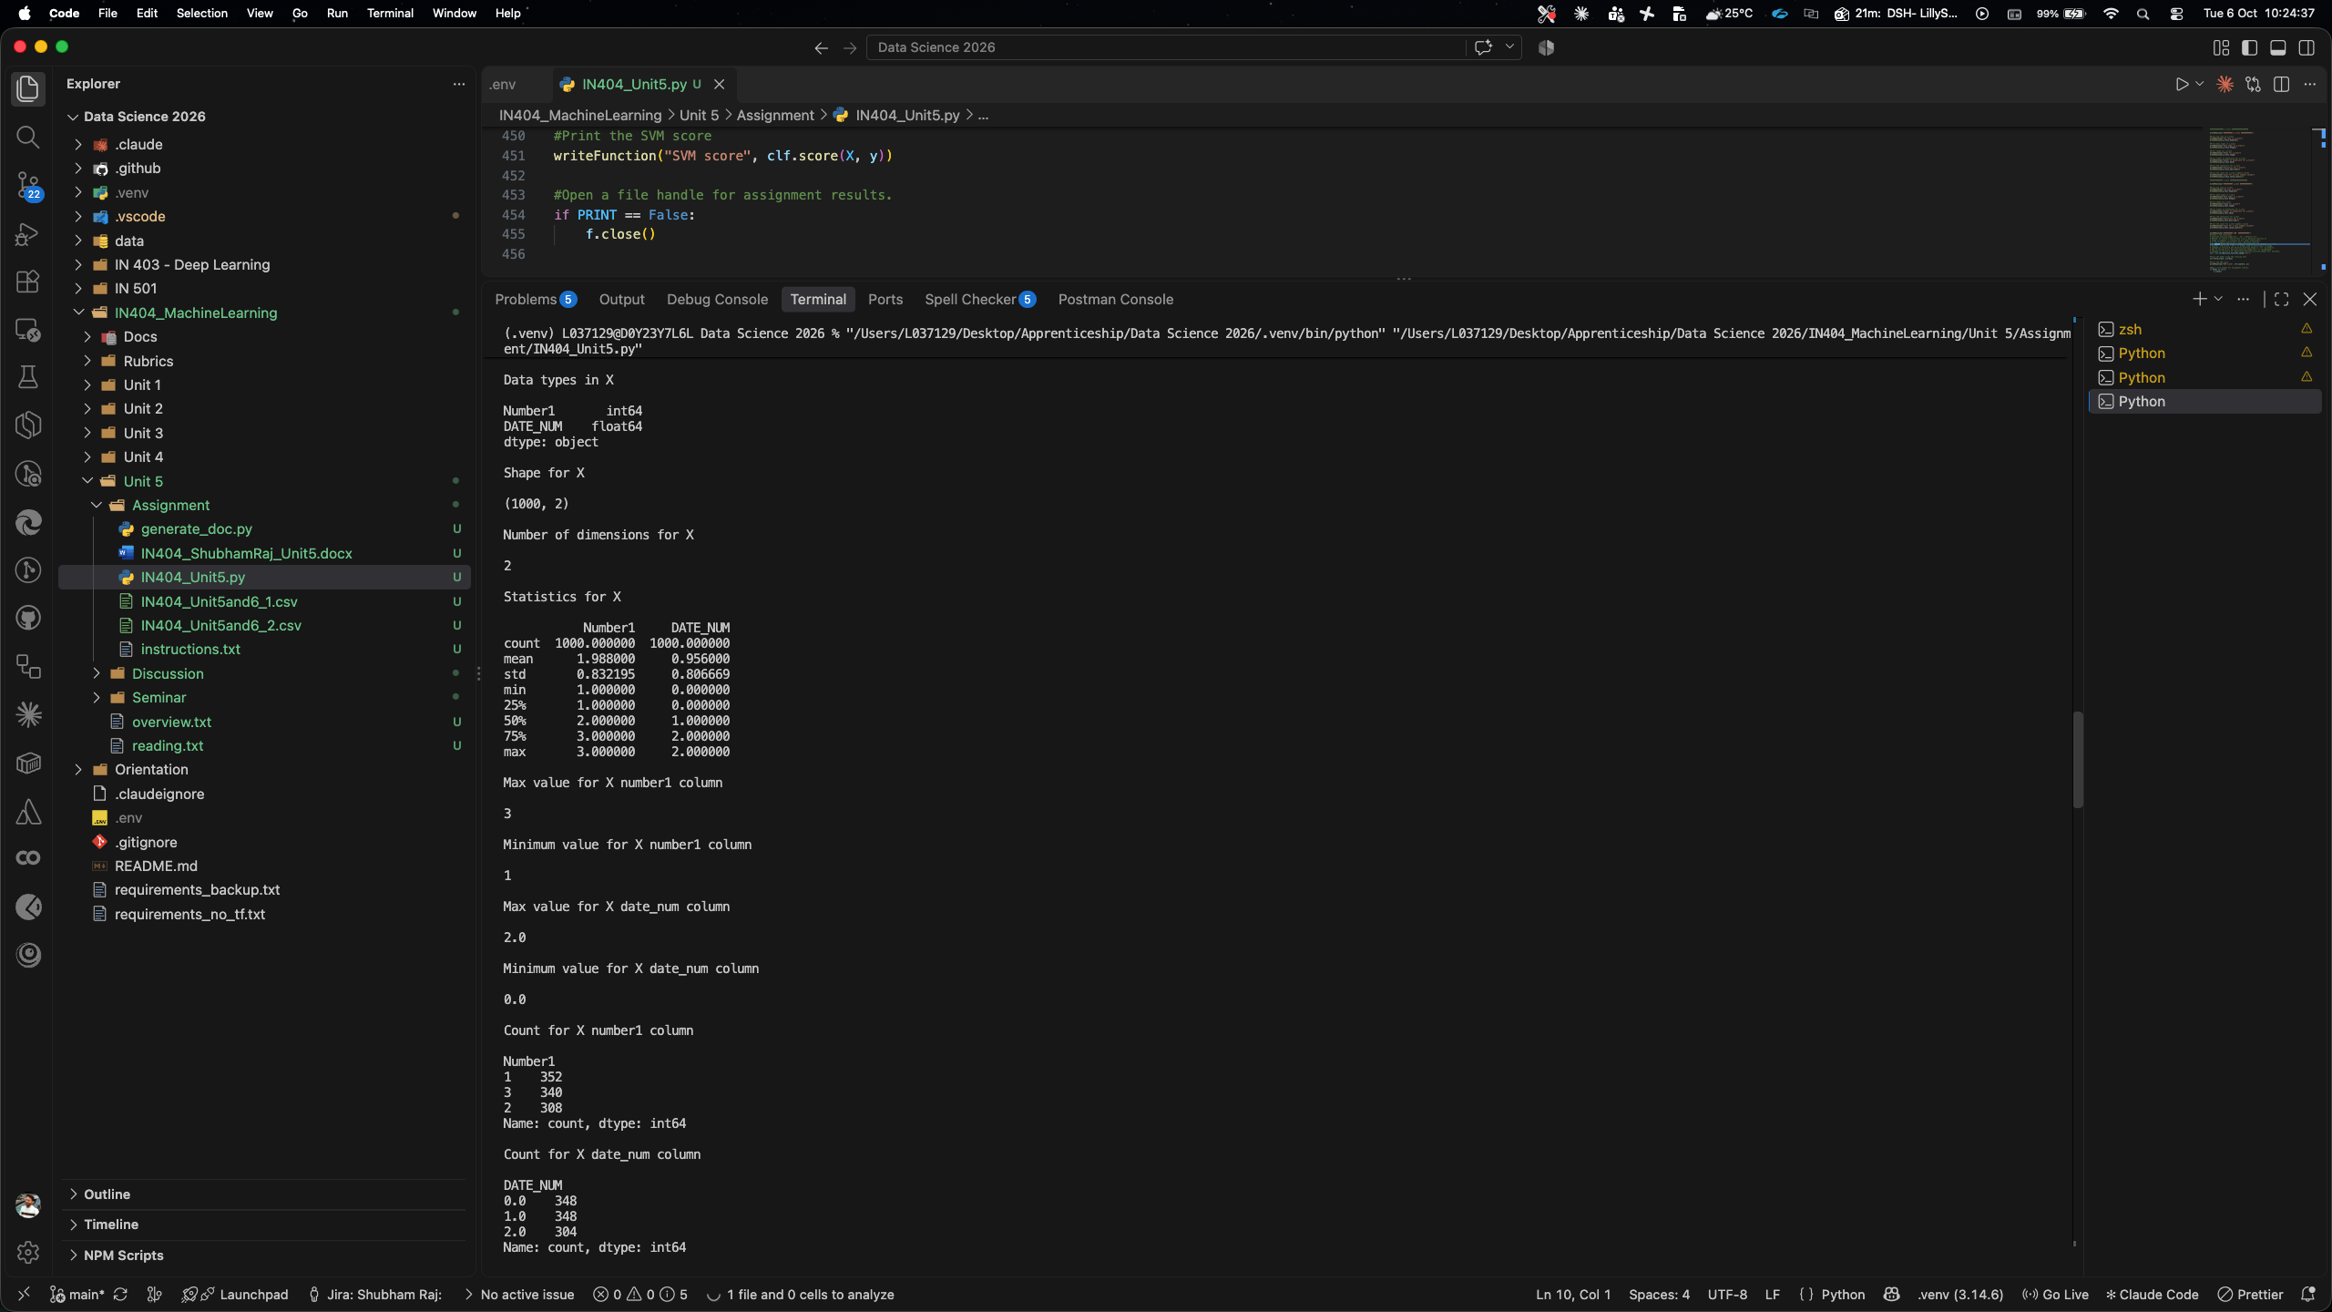
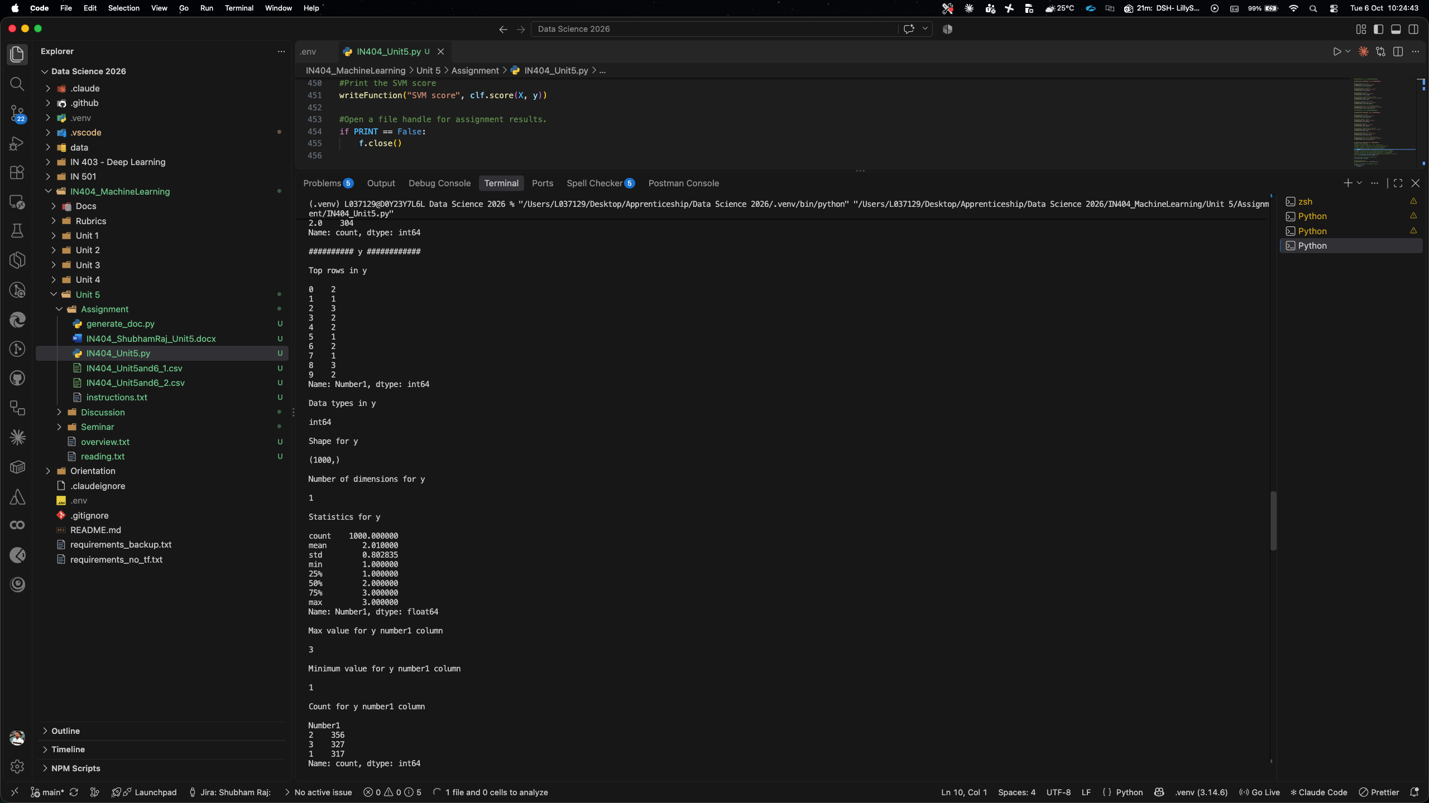
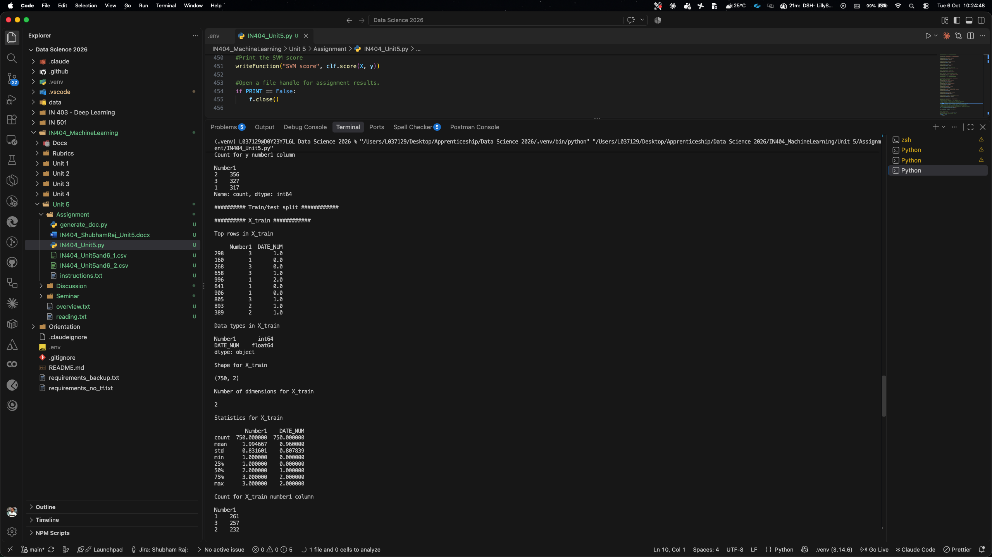
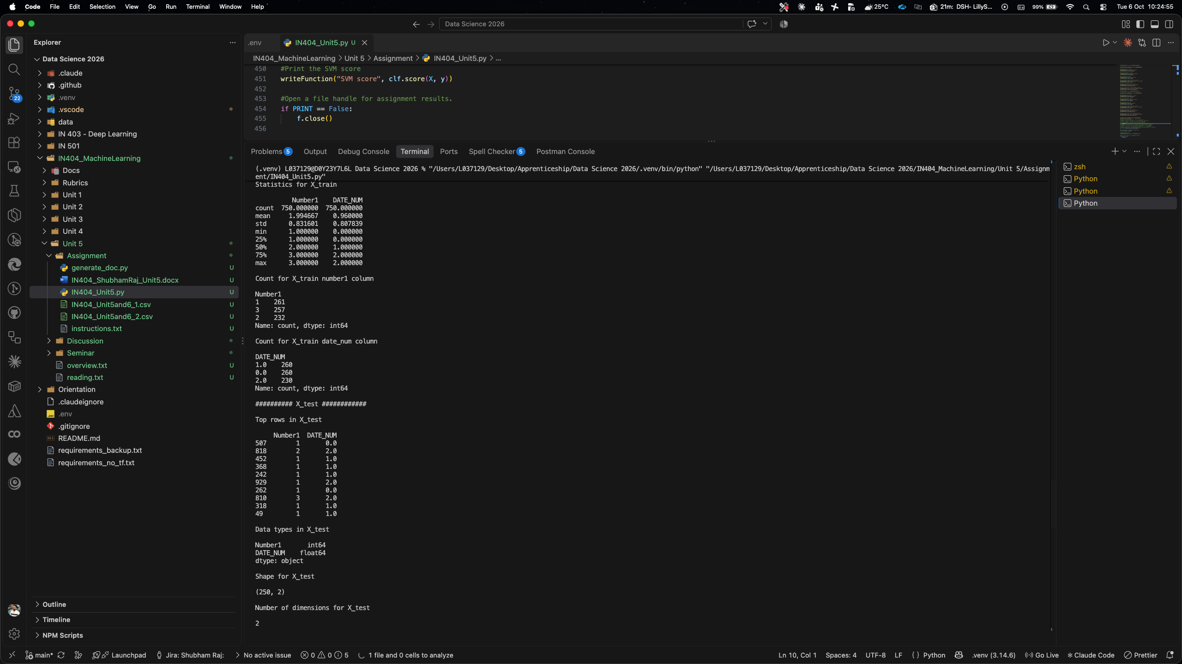
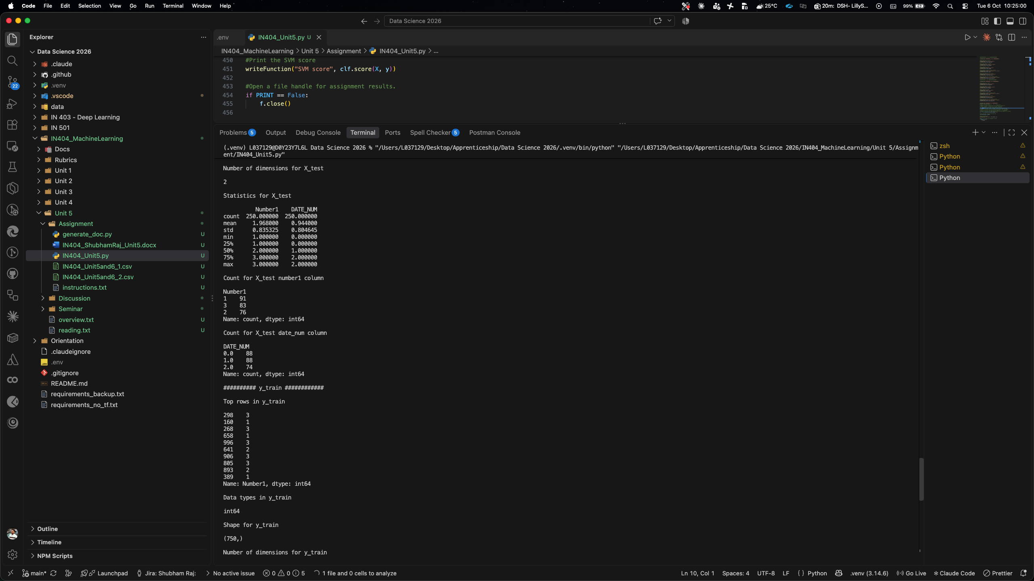
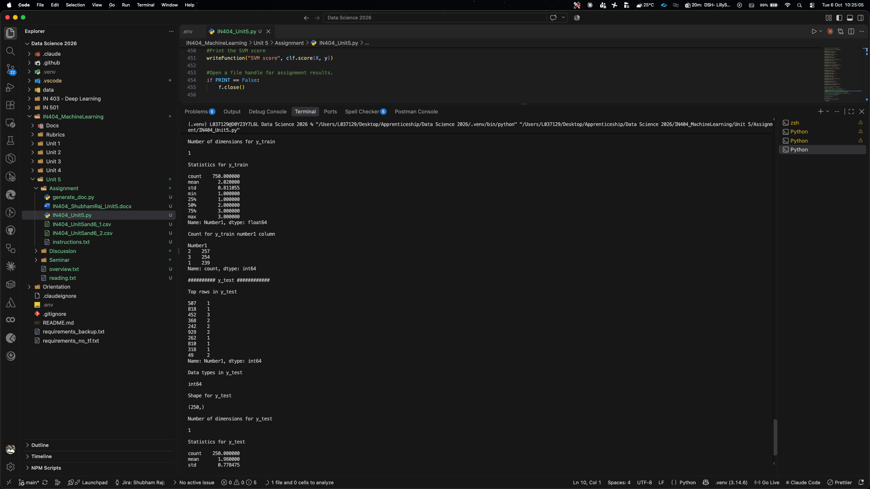
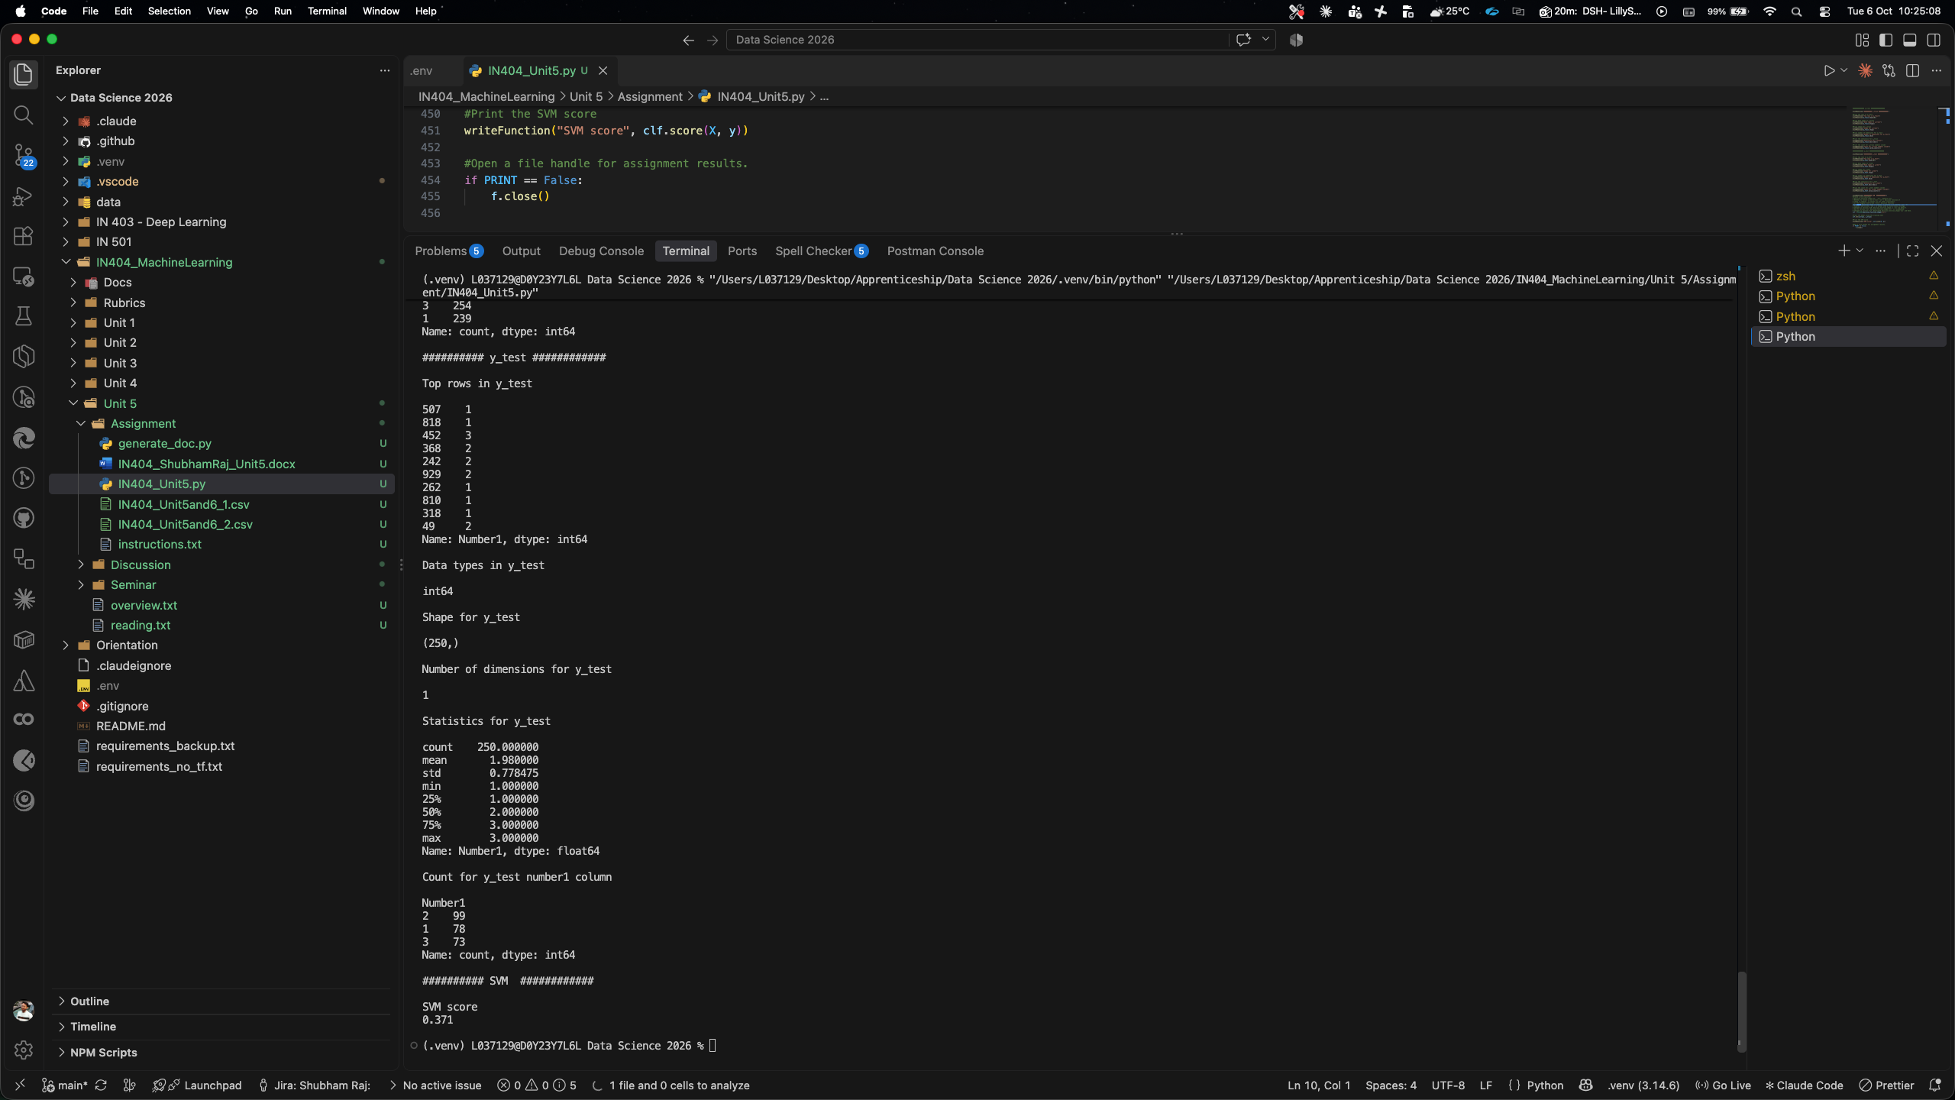

2. Shapes of Each Dataset
df2: (1000, 2) — I found that Dataframe 2 has 1,000 rows and 2 columns (Number1 and Number2).
df1 after datetime conversion to float: (1000, 3) — After I added the DATE_NUM column, Dataframe 1 has 1,000 rows and 3 columns (Number1, Date, and DATE_NUM).
X: (1000, 2) — My feature matrix X contains 1,000 rows and 2 columns (Number1 and DATE_NUM).
y: (1000,) — My target vector y is a one-dimensional Series with 1,000 elements (Number1 from df2).
X_train: (750, 2) — My training feature set has 750 rows and 2 columns.
X_test: (250, 2) — My testing feature set has 250 rows and 2 columns.
y_train: (750,) — My training target set has 750 elements.
y_test: (250,) — My testing target set has 250 elements.

3. Why the Date Column Was Converted to Datetime and Then to Float
I found that the Date column in df1 was originally stored as a string (object dtype) in the format "2/4/20". Since machine learning algorithms, including SVM, require all input features to be numeric, I could not feed a string directly into the model (Pedregosa et al., 2011).
I performed the conversion in two steps. First, I used pd.to_datetime() to parse the string into a proper datetime64 type, which gives Python an understanding of the chronological order and the actual calendar distances between dates (McKinney, 2017). Second, I converted the datetime to a float by computing the number of days since the earliest date in the column (df1['Date'].min()). Dividing by np.timedelta64(1, 'D') turns the timedelta into a simple floating-point number of days (0.0, 1.0, 2.0, etc.).
This two-step approach preserves the meaningful time relationships between the dates (e.g., February 6 is two days after February 4) while producing a numeric feature that the SVM algorithm can process. If I had simply label-encoded the dates as arbitrary integers, the relative distances between dates might not have been preserved correctly.

4. Train/Test Split Values
I used the train_test_split() function from scikit-learn with default parameters (and random_state=1 for reproducibility). By default, scikit-learn uses a 75% train / 25% test split.
With 1,000 total samples, I obtained:
- Training set: 750 samples (75%)
- Testing set: 250 samples (25%)
I confirmed this by the shapes: X_train is (750, 2), X_test is (250, 2), y_train is (750,), and y_test is (250,).

5. Support Vector Machine (SVM) and Kernel Learning
From my research, a Support Vector Machine (SVM) is a supervised machine learning algorithm used primarily for classification tasks, though it can also be applied to regression (Cortes & Vapnik, 1995). The fundamental idea behind SVM is to find the optimal hyperplane that maximally separates data points belonging to different classes in the feature space. The data points closest to this decision boundary are called "support vectors," and they are the critical elements that define the position and orientation of the hyperplane.
I learned that kernel learning is what makes SVM especially powerful. When data is not linearly separable in its original feature space, the kernel trick maps the data into a higher-dimensional space where a linear separator can be found (Hastie et al., 2009). Common kernel functions include the linear kernel, polynomial kernel, radial basis function (RBF) kernel (which is the default in scikit-learn's SVC), and the sigmoid kernel. The kernel function computes the similarity between data points in this higher-dimensional space without explicitly performing the transformation, making the computation efficient.
I found that SVM is used for tasks such as text classification, image recognition, bioinformatics, and any scenario where clear class separation is desired. It works well with high-dimensional data and is effective even when the number of dimensions exceeds the number of samples (Pedregosa et al., 2011).

6. SVM Decision Function Shapes: OVO and OVR
I learned that SVM was originally designed for binary (two-class) classification. To handle multi-class problems (like this assignment, where y has three classes: 1, 2, and 3), two common strategies are used (Pedregosa et al., 2011):
One-vs-One (OVO): This strategy builds one classifier for every pair of classes. For k classes, it creates k × (k − 1) / 2 binary classifiers. For my 3-class problem, that means 3 classifiers (class 1 vs. 2, class 1 vs. 3, and class 2 vs. 3). Each classifier votes on the class, and the class with the most votes wins. The decision function shape is (n_samples, n_classes × (n_classes − 1) / 2). In scikit-learn, OVO is always used internally as the multi-class strategy regardless of the decision_function_shape setting.
One-vs-Rest (OVR): This strategy builds one classifier per class, where each classifier separates one class from all others combined. For k classes, it creates k binary classifiers. The decision function shape is (n_samples, n_classes). Since version 0.19, OVR is the default decision_function_shape in scikit-learn and is the recommended setting, which is what I used in my code: svm.SVC(decision_function_shape='ovr').

7. SVM Score
The SVM score produced by my program is 0.371 (37.1%).

8. Meaning of the SVM Score as Applied to X and y
I used clf.score(X, y), which returns the mean accuracy of the SVM model on the given data. It compares the model's predictions for every sample in X against the true labels in y, and reports the proportion that were classified correctly (Pedregosa et al., 2011).
My score of 0.371 means the model correctly classified only 37.1% of the 1,000 samples. This is a low accuracy score — barely better than random guessing for a 3-class problem (which would yield roughly 33.3% accuracy by chance). This tells me that the features in X (Number1 and DATE_NUM from df1) are not strong predictors of the target variable y (Number1 from df2). The two datasets may not have a meaningful relationship that the SVM can learn, which makes sense given that the feature values and target values appear to be largely independent of each other.
I also noted that clf.score(X, y) evaluates on the full dataset (all 1,000 samples), not just the test set. Evaluating on the training data as well can sometimes inflate the score, but even with that advantage my accuracy remains very low, reinforcing that the model has not found a useful pattern in the data.

References
Cortes, C., & Vapnik, V. (1995). Support-vector networks. Machine Learning, 20(3), 273–297. https://doi.org/10.1007/BF00994018
Hastie, T., Tibshirani, R., & Friedman, J. (2009). The elements of statistical learning: Data mining, inference, and prediction (2nd ed.). Springer. https://doi.org/10.1007/978-0-387-84858-7
McKinney, W. (2017). Python for data analysis: Data wrangling with Pandas, NumPy, and IPython (2nd ed.). O'Reilly Media.
Pedregosa, F., Varoquaux, G., Gramfort, A., Michel, V., Thirion, B., Grisel, O., Blondel, M., Prettenhofer, P., Weiss, R., Dubourg, V., Vanderplas, J., Passos, A., Cournapeau, D., Brucher, M., Perrot, M., & Duchesnay, E. (2011). Scikit-learn: Machine learning in Python. Journal of Machine Learning Research, 12, 2825–2830. https://jmlr.org/papers/v12/pedregosa11a.html

